_________’S MORNING SCHEDULE
BREAKFAST | GET DRESSED | BRUSH TEETH | PUT SHOES ON | PUT JACKET ON | GET BACKPACK | OFF TO SCHOOL!
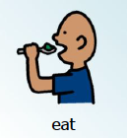 | 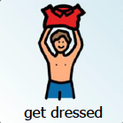 | 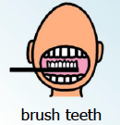 | 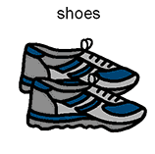 | 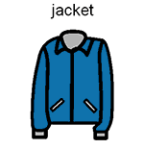 | 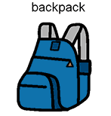 | school  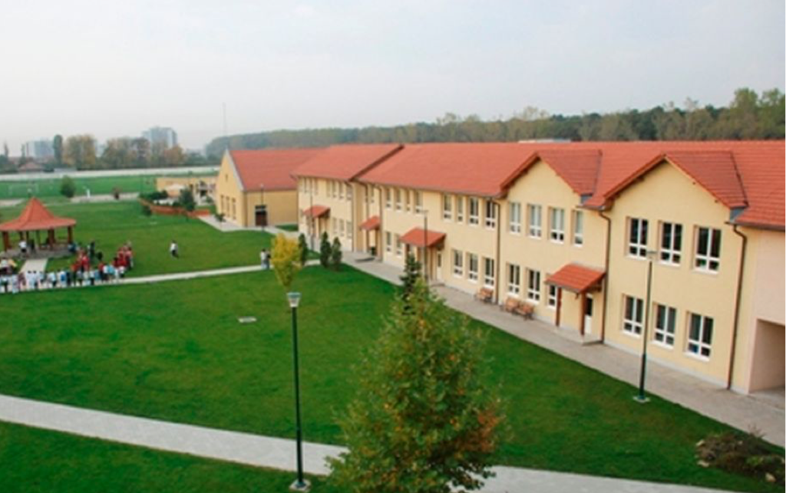

_______________’S MORNING CHECKLIST

Get dressed (don’t forget camisole or bra)
Brush hair
Wash face
Brush teeth
Get socks and shoes together by the door
Leave for school!

____________’S EVENING CHECKLIST
 | Snack / Break
 | Homework
 | Dinner
 | Homework (if more time is needed)
 | Free Time (Wednesdays and Thursdays)
 | Get backpack together for school (lunch money on Sunday)
 | Put PJ’s on
 | Wash face / shower
 | Brush teeth
 | Lay out clothes for tomorrow (don’t forget bra/camisole)
 | Get bread and ingredients out for breakfast
 | Read book of choice
9:15pm | Light’s Out!

